
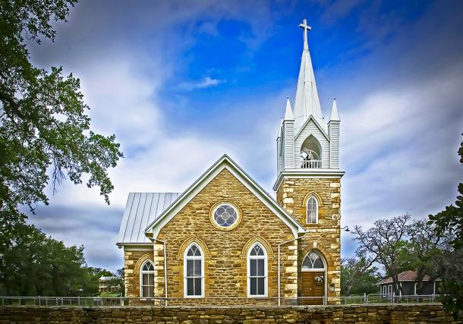
Classic games for the kids! Bring the whole family.

October 8, 2017
4:00 PM Gathering, Music, and Worship followed by Silent Auction, Food & Fellowship
FMI: 325-762-6100
  - Hilda United Methodist Church

Camp Meeting

