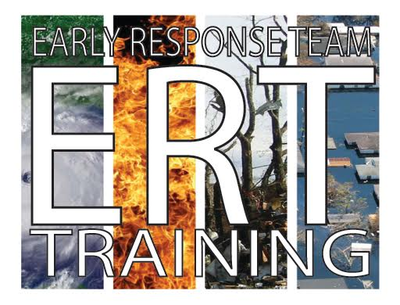

ERT Basic Training at
Sierra Vista UMC
4522 College Hills Blvd, San Angelo
on January 29, 2022
from 8:30am to 4:30pm
For more information or to register go to: https://riotexasresponse.org/ert-basic

“Are you Ready, Are you Able, Are you Willing?”
There is something for everyone to do.

For questions or concerns, please contact Ginnie Street, Rio Texas Conference Disaster Response Training Coordinator at 512-203-7730 or training@riotexasresponse.org

